LARAVEL DOCUMITATION
Laravel is an open-source PHP framework, which is robust and easy to understand. It follows a model-view-controller design pattern. Laravel reuses the existing components of different frameworks which helps in creating a web application. The web application thus designed is more structured and pragmatic.
Laravel offers a rich set of functionalities which incorporates the basic features of PHP frameworks like CodeIgniter, Yii and other programming languages like Ruby on Rails. Laravel has a very rich set of features which will boost the speed of web development.

Advantages of Laravel

- The web application becomes more scalable, owing to the Laravel framework.
- Considerable time is saved in designing the web application, since Laravel reuses the components from other framework in developing web application.
- It includes namespaces and interfaces, thus helps to organize and manage resources.

Composer
Composer is a tool which includes all the dependencies and libraries. It allows a user to create a project with respect to the mentioned framework (for example, those used in Laravel installation). Third party libraries can be installed easily with help of composer.
All the dependencies are noted in composer.json file which is placed in the source folder.

Features of Laravel
Laravel offers the following key features which makes it an ideal choice for designing web applications −
Modularity
Laravel provides 20 built in libraries and modules which helps in enhancement of the application. Every module is integrated with Composer dependency manager which eases updates.
Testability
Laravel includes features and helpers which helps in testing through various test cases. This feature helps in maintaining the code as per the requirements.
Routing
Laravel provides a flexible approach to the user to define routes in the web application. Routing helps to scale the application in a better way and increases its performance.
Configuration Management
A web application designed in Laravel will be running on different environments, which means that there will be a constant change in its configuration. Laravel provides a consistent approach to handle the configuration in an efficient way.
Query Builder and ORM
Laravel incorporates a query builder which helps in querying databases using various simple chain methods. It provides ORM (Object Relational Mapper) and ActiveRecord implementation called Eloquent.
Schema Builder
Schema Builder maintains the database definitions and schema in PHP code. It also maintains a track of changes with respect to database migrations.
Template Engine
Laravel uses the Blade Template engine, a lightweight template language used to design hierarchical blocks and layouts with predefined blocks that include dynamic content.
E-mail
Laravel includes a mail class which helps in sending mail with rich content and attachments from the web application.
Authentication
User authentication is a common feature in web applications. Laravel eases designing authentication as it includes features such as register, forgot password and send password reminders.
Redis
Laravel uses Redis to connect to an existing session and general-purpose cache. Redis interacts with session directly.
Queues
Laravel includes queue services like emailing large number of users or a specified Cron job. These queues help in completing tasks in an easier manner without waiting for the previous task to be completed.
Event and Command Bus
Laravel 5.1 includes Command Bus which helps in executing commands and dispatch events in a simple way. The commands in Laravel act as per the application’s lifecycle.

MVC MODEL VIEW CONTROLLER
Explained by jainik sir model holds our database view holds the UI part
And controller placed the Logics in another words we can say Api integration
OUR WORK
MODEL AND CONTROLLER ITS OUR PART
API INTIGRATION -DEFIND ONE BACKEND AND USE TWICE TO SEND THE DIFFERENT
USER INTER FACE AS BEING CONVERTED IN API
Why MVC ?
It is mainly used to separate Application code into user interfaces, data, and controlling logic. It can benefit the developer to easily maintain the code which can help to make a development process much smooth

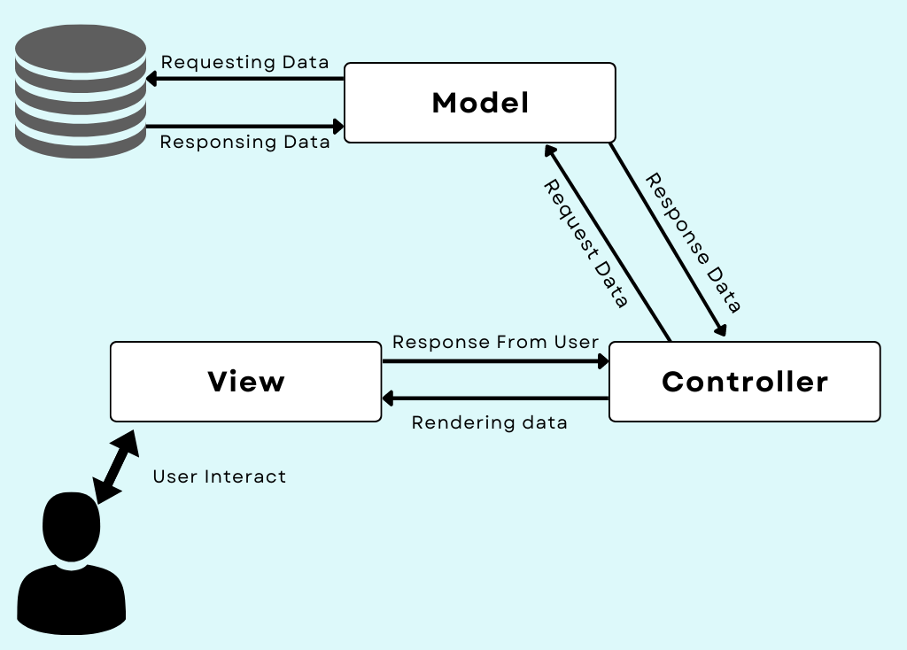

Model:
This component of the MVC framework handles data used in your application. It helps to retrieve the data from the database and then perform some operation that your application is supposed to perform then it stores that data back in the database.
In simple words, we can say that Model is responsible for managing data that is passed between the database and the User Interface (View).
View:
This component is User Interface, which defines the template which is sent as a response to the browser. This View components contain the part of code which helps to display data to the User Interface on the user’s browser. For example, we can say the buttons, textbox, dropdown menu, and many more such widgets on the browser screen are the part of View Component.
Controller:
This controller component helps to interact with the model component to fetch data from the database and then pass that data to the view component to get the desired output on the user’s browser screen. Same way, when the user enters some data the controller fetches that data and then performs some operation or just inserts that data into the database with the use of the model components.
MVC DEEP OVERVIEW
MODEL :
Used to apply for the business or complex logic and which fields wants from the database
VIEW :
Used to store browser UI
CONTROLLER :
Controllee will handle intraction between database and UI OR VIEW

LARVEL VERSION COMHPERSION

- LARAVEL VERSION 6X AND 7X

- BOTH ARE USING PHP VERSION 7.2

he primary difference between Laravel versions 6 and 7 is theIntroduction of "Laravel Sanctum" in version 7, a dedicated authentication system for API applications, alongside various improvements in routing speed, Blade component support, CORS management, and enhanced Eloquent features, making Laravel 7 significantly more focused on API development compared to version 6; Additionally, version 7 requires a newer Symfony version and may have changes in date serialization and other minor features.
Key points about the differences:
- Sanctum:
Laravel 7 introduced Sanctum, a dedicated API authentication system, while version 6 lacks this feature.
- Blade Components:
While Blade components were available in version 6, Laravel 7 significantly enhanced their functionality with new features and syntax improvements.
- CORS Support:
Version 7 includes built-in CORS (Cross-Origin Resource Sharing) support, which was not as readily available in version 6.
- Improved Routing:
Laravel 7 boasts performance enhancements in routing compared to version 6.
- Dependency Updates:
Upgrading from version 6 to 7 typically requires updating to a newer Symfony version.

- LARAVEL VERSION 7X AND 8X

The primary difference between Laravel 7 and 8 is the introduction of "Laravel Jetstream" in version 8, a comprehensive authentication scaffolding system that offers features like email verification, two-factor authentication, and profile management, whereas Laravel 7 primarily focused on the Sanctum package for API authentication and lacked such robust user interface features for authentication flows; additionally, Laravel 8 includes improvements to model factories, migration squashing, job batching, better rate limiting, and enhanced Blade component capabilities compared to Laravel 7.
Key points about the differences:
- Authentication system:
Laravel 7 mainly uses Sanctum for API authentication, while Laravel 8 introduces Jetstream, a full-fledged authentication system with a richer user interface and features.
- UI improvements:
Laravel 8 leverages Tailwind CSS in Jetstream, providing a more modern and customizable look compared to Laravel 7.
- Model management:
Laravel 8 offers enhanced model factories and migration squashing capabilities for better database management.
- Job handling:
Job batching is introduced in Laravel 8, allowing for better management of queued jobs.
- Rate Limiting:
Laravel 8 has improved rate limiting features compared to Laravel

- LARAVEL VERSION 8X AND 9X

The primary difference between Laravel version 8 and 9 is that Laravel 9 incorporates several new features and improvements built upon the foundation of Laravel 8, including a mandatory upgrade to PHP 8.0, the adoption of Symfony Mailer instead of SwiftMailer for email sending, integration with Flysystem 3.x for file system operations, enhanced Eloquent accessors and mutators, and improved route listing output; essentially, Laravel 9 offers a more modern and streamlined development experience with updated dependencies and functionalities compared to Laravel 8.
Key points about the differences:
- PHP version requirement:
Laravel 9 requires a minimum PHP version of 8.0, while Laravel 8 can work with slightly older PHP versions.
- Mailer integration:
Laravel 9 uses Symfony Mailer for sending emails, whereas Laravel 8 utilizes the older SwiftMailer library.
- Flysystem version:
Laravel 9 integrates with Flysystem 3.x, providing updated file system management capabilities.
- Eloquent improvements:
Laravel 9 features enhanced Eloquent accessors and mutators for more refined data manipulation.
- Other updates:
Laravel 9 includes various bug fixes, better route listing output, and support for new features like implicit route bindings via Enum

- LARAVEL VERSION 9X AND 10X

The primary difference between Laravel version 9 and 10 is that Laravel 10 introduces several new features and improvements, including better support for type hinting, a dedicated feature flag package called "Laravel Pennant", enhanced testing capabilities, and a requirement for PHP version 8.1 or higher, while Laravel 9 supports older PHP versions and has a slightly smaller feature set.
Key points about Laravel 10 compared to Laravel 9:
- PHP version requirement:
Laravel 10 mandates using PHP 8.1 or above, whereas Laravel 9 can work with older PHP versions like 8.0.
- Laravel Pennant:
Laravel 10 includes a built-in feature flag package called "Laravel Pennant" for managing application features.
- Improved type hinting:
Laravel 10 utilizes native PHP type hints throughout the application skeleton, providing better code clarity.
- Testing enhancements:
Laravel 10 offers new testing features like the ability to easily identify slow-running tests.

While Laravel versions 10, 11, and 12 all share a core framework, the key difference lies in the newer features and improvements introduced with each subsequent release,
LARAVEL DAY 2

- LARAVEL VERSION 10X,11X AND 12X

including enhancements like per-second rate limiting in Laravel 11, streamlined application structure, and further integration with modern frontend frameworks like React and Vue in Laravel 12, alongside updated dependencies and potential new starter kits for authentication solutions like WorkOS AuthKit.
Key points about each version:
- Laravel 10:
Introduced "Laravel Pennant" for feature flags management, improved test identification for slow-running tests, and adopted invokable validation rules by default.
- Laravel 11:
Added per-second rate limiting, Resend mail transport, Prompt validator integration, improved queue testing capabilities, and a more minimal application skeleton.
- Laravel 12:
Continued improvements from Laravel 11, with a focus on updated starter kits for React, Vue, and Livewire, potentially including options to use WorkOS AuthKit for user authentication with social login and SSO feature

LARAVEL 10th VERSION R&D AND IMPLMETION

Creating a Laravel Project

Before creating your first Laravel project, make sure that your local machine has PHP and Composer installed. If you are developing on macOS, PHP and Composer can be installed in minutes via Laravel Herd. In addition, we recommend installing Node and NPM.

After you have installed PHP and Composer, you may create a new Laravel project via Composer's create-project command:

composer create-project "laravel/laravel:^10.0" example-app

Or, you may create new Laravel projects by globally installing the Laravel installer via Composer:

composer global require laravel/installer

laravel new example-app

Once the project has been created, start Laravel's local development server using
Laravel Artisan's serve command:

cd example-app
php artisan serve

Directory Structure
- Introduction
- The Root Directory
  - The app Directory
  - The bootstrap Directory
  - The config Directory
  - The database Directory
  - The public Directory
  - The resources Directory
  - The routes Directory
  - The storage Directory
  - The tests Directory
  - The vendor Directory
- The App Directory
  - The Broadcasting Directory
  - The Console Directory
  - The Events Directory
  - The Exceptions Directory
  - The Http Directory
  - The Jobs Directory
  - The Listeners Directory
  - The Mail Directory
  - The Models Directory
  - The Notifications Directory
  - The Policies Directory
  - The Providers Directory
  - The Rules Directory

The App Directory
The app directory contains the core code of your application. We'll explore this directory in more detail soon; however, almost all of the classes in your application will be in this directory.
The Bootstrap Directory
The bootstrap directory contains the app.php file which bootstraps the framework. This directory also houses a cache directory which contains framework generated files for performance optimization such as the route and services cache files. You should not typically need to modify any files within this directory.
The Config Directory
The config directory, as the name implies, contains all of your application's configuration files. It's a great idea to read through all of these files and familiarize yourself with all of the options available to you.
The Database Directory
The database directory contains your database migrations, model factories, and seeds. If you wish, you may also use this directory to hold an SQLite database.
The Public Directory
The public directory contains the index.php file, which is the entry point for all requests entering your application and configures autoloading. This directory also houses your assets such as images, JavaScript, and CSS.

LARAVEL DAY 3

The Resources Directory
The resources directory contains your views as well as your raw, un-compiled assets such as CSS or JavaScript.

The Routes Directory
The routes directory contains all of the route definitions for your application. By default, several route files are included with Laravel: web.php, api.php, console.php, and channels.php.
The web.php file contains routes that the RouteServiceProvider places in the web middleware group, which provides session state, CSRF protection, and cookie encryption. If your application does not offer a stateless, RESTful API then all your routes will most likely be defined in the web.php file.
The api.php file contains routes that the RouteServiceProvider places in the api middleware group. These routes are intended to be stateless, so requests entering the application through these routes are intended to be authenticated via tokens and will not have access to session state.
The console.php file is where you may define all of your closure based console commands. Each closure is bound to a command instance allowing a simple approach to interacting with each command's IO methods. Even though this file does not define HTTP routes, it defines console based entry points (routes) into your application.
The channels.php file is where you may register all of the event broadcasting channels that your application supports.

The storage directory

In Laravel, a "storage" file is essential because it provides a structured way to store various types of data like uploaded files, user profile images, generated documents, and temporary session data within your application, allowing you to manage file operations easily and consistently across different storage options like local servers or cloud services like Amazon S3, without needing to manually handle complex file system interactions on your server.

The Tests Directory
The tests directory contains your automated tests. Example PHPUnit unit tests and feature tests are provided out of the box. Each test class should be suffixed with the word Test. You may run your tests using the phpunit or php vendor/bin/phpunit commands. Or, if you would like a more detailed and beautiful representation of your test results, you may run your tests using the php artisan test Artisan command.

The Vendor Directory
The vendor directory contains your Composer dependencies.

The App Directory
The majority of your application is housed in the app directory. By default, this directory is namespaced under App and is autoloaded by Composer using the PSR-4 autoloading standard.
The app directory contains a variety of additional directories such as Console, Http, and Providers. Think of the Console and Http directories as providing an API into the core of your application. The HTTP protocol and CLI are both mechanisms to interact with your application, but do not actually contain application logic. In other words, they are two ways of issuing commands to your application. The Console directory contains all of your Artisan commands, while the Http directory contains your controllers, middleware, and requests.
A variety of other directories will be generated inside the app directory as you use the make Artisan commands to generate classes. So, for example, the app/Jobs directory will not exist until you execute the make:job Artisan command to generate a job class.

LIVEWIRE
Livewire
Laravel Livewire is a framework for building Laravel powered frontends that feel dynamic, modern, and alive just like frontends built with modern JavaScript frameworks like Vue and React.
When using Livewire, you will create Livewire "components" that render a discrete portion of your UI and expose methods and data that can be invoked and interacted with from your application's frontend. For example, a simple "Counter" component might look like the following:

vel Jetstream
While Laravel Breeze provides a simple and minimal starting point for building a Laravel application, Jetstream augments that functionality with more robust features and additional frontend technology stacks. For those brand new to Laravel, we recommend learning the ropes with Laravel Breeze before graduating to Laravel Jetstream.
Jetstream provides a beautifully designed application scaffolding for Laravel and includes login, registration, email verification, two-factor authentication, session management, API support via Laravel Sanctum, and optional team management. Jetstream is designed using Tailwind CSS and offers your choice of Livewire or Inertia driven frontend scaffolding.
Complete documentation for installing Laravel Jetstream can be found within the official Jetstream documentation.

APPLICATION DEPLOYMENT RULES AND REGULATION

Server Requirements
The Laravel framework has a few system requirements. You should ensure that your web server has the following minimum PHP version and extensions:
- PHP >= 8.1
- Ctype PHP Extension
- cURL PHP Extension
- DOM PHP Extension
- Fileinfo PHP Extension
- Filter PHP Extension
- Hash PHP Extension
- Mbstring PHP Extension
- OpenSSL PHP Extension
- PCRE PHP Extension
- PDO PHP Extension
- Session PHP Extension
- Tokenizer PHP Extension
- XML PHP Extension

Server Configuration
Nginx
If you are deploying your application to a server that is running Nginx, you may use the following configuration file as a starting point for configuring your web server. Most likely, this file will need to be customized depending on your server's configuration. If you would like assistance in managing your server, consider using a first-party Laravel server management and deployment service such as Laravel Forge.
Please ensure, like the configuration below, your web server directs all requests to your application's public/index.php file. You should never attempt to move the index.php file to your project's root, as serving the application from the project root will expose many sensitive configuration files to the public Internet:

Lifecycle Overview
First Steps
The entry point for all requests to a Laravel application is the public/index.php file. All requests are directed to this file by your web server (Apache / Nginx) configuration. The index.php file doesn't contain much code. Rather, it is a starting point for loading the rest of the framework.
The index.php file loads the Composer generated autoloader definition, and then retrieves an instance of the Laravel application from bootstrap/app.php. The first action taken by Laravel itself is to create an instance of the application / service container.
HTTP / Console Kernels
Next, the incoming request is sent to either the HTTP kernel or the console kernel, depending on the type of request that is entering the application. These two kernels serve as the central location that all requests flow through. For now, let's just focus on the HTTP kernel, which is located in app/Http/Kernel.php.
The HTTP kernel extends the Illuminate\Foundation\Http\Kernel class, which defines an array of bootstrappers that will be run before the request is executed. These bootstrappers configure error handling, configure logging, detect the application environment, and perform other tasks that need to be done before the request is actually handled. Typically, these classes handle internal Laravel configuration that you do not need to worry about.
The HTTP kernel also defines a list of HTTP middleware that all requests must pass through before being handled by the application. These middleware handle reading and writing the HTTP session, determining if the application is in maintenance mode, verifying the CSRF token, and more. We'll talk more about these soon.
The method signature for the HTTP kernel's handle method is quite simple: it receives a Request and returns a Response. Think of the kernel as being a big black box that represents your entire application. Feed it HTTP requests and it will return HTTP responses.

LARAVEL DAY 5

FOLDER STRUCTURE AND FILE STRUCTURE

- Main folder structure for beginners
- App >> HTTP >> Controllers
- Database >> Migrations
- Env File For Configuration of database and migrations
- Resources >> Views >> Blade Templates >>Welcome.Php
- Routes >> web.php

Easy Deployment With Forge / Vapor
Laravel Forge
If you aren't quite ready to manage your own server configuration or aren't comfortable configuring all of the various services needed to run a robust Laravel application, Laravel Forge is a wonderful alternative.
Laravel Forge can create servers on various infrastructure providers such as DigitalOcean, Linode, AWS, and more. In addition, Forge installs and manages all of the tools needed to build robust Laravel applications, such as Nginx, MySQL, Redis, Memcached, Beanstalk, and more.
Want a full guide to deploying with Laravel Forge? Check out the Laravel Bootcamp and the Forge video series available on Laracasts.
Laravel Vapor
If you would like a totally serverless, auto-scaling deployment platform tuned for Laravel, check out Laravel Vapor. Laravel Vapor is a serverless deployment platform for Laravel, powered by AWS. Launch your Laravel infrastructure on Vapor and fall in love with the scalable simplicity of serverless. Laravel Vapor is fine-tuned by Laravel's creators to work seamlessly with the framework so you can keep writing your Laravel applications exactly like you're used to.

Lifecycle Overview
First Steps
The entry point for all requests to a Laravel application is the public/index.php file. All requests are directed to this file by your web server (Apache / Nginx) configuration. The index.php file doesn't contain much code. Rather, it is a starting point for loading the rest of the framework.
The index.php file loads the Composer generated autoloader definition, and then retrieves an instance of the Laravel application from bootstrap/app.php. The first action taken by Laravel itself is to create an instance of the application / service container.

LARAVEL DAY 6

The Laravel service container is a powerful tool for managing class dependencies and performing dependency injection. Dependency injection is a fancy phrase that essentially means this: class dependencies are "injected" into the class via the constructor or, in some cases, "setter" methods.

ntroduction
Service providers are the central place of all Laravel application bootstrapping. Your own application, as well as all of Laravel's core services, are bootstrapped via service providers.
But, what do we mean by "bootstrapped"? In general, we mean registering things, including registering service container bindings, event listeners, middleware, and even routes. Service providers are the central place to configure your application.
If you open the config/app.php file included with Laravel, you will see a providers array. These are all of the service provider classes that will be loaded for your application. By default, a set of Laravel core service providers are listed in this array. These providers bootstrap the core Laravel components, such as the mailer, queue, cache, and others. Many of these providers are "deferred" providers, meaning they will not be loaded on every request, but only when the services they provide are actually needed.
In this overview, you will learn how to write your own service providers and register them with your Laravel application.
If you would like to learn more about how Laravel handles requests and works internally, check out our documentation on the Laravel request lifecycle.
Writing Service Providers
All service providers extend the Illuminate\Support\ServiceProvider class. Most service providers contain a register and a boot method. Within the register method, you should only bind things into the service container. You should never attempt to register any event listeners, routes, or any other piece of functionality within the register method.
The Artisan CLI can generate a new provider via the make:provider command:
1php artisan make:provider RiakServiceProvider
The Register Method
As mentioned previously, within the register method, you should only bind things into the service container. You should never attempt to register any event listeners, routes, or any other piece of functionality within the register method. Otherwise, you may accidentally use a service that is provided by a service provider which has not loaded yet.
Let's take a look at a basic service provider. Within any of your service provider methods, you always have access to the $app property which provides access to the service container:

SINGLETONE

The singleton method binds a class or interface into the container that should only be resolved one time. Once a singleton binding is resolved, the same object instance will be returned on subsequent calls into the container:

LARAVEL DAY 7

CREATE SERVICE

php artisan make:provider RiakServiceProvider

APP SERVICE PROVIDER FILE

<?php

namespace App\Providers;

use App\Models\User;
use Illuminate\Console\Application as ConsoleApplication;
use Illuminate\Contracts\Foundation\Application;
use Illuminate\Support\ServiceProvider;

class AppServiceProvider extends ServiceProvider
{
/**
* Register any application services.
*/
public function register(): void
{
app()->bind('helo',function(){
return "hii";
});
}

/**
* Bootstrap any application services.
*/
public function boot(): void
{
//
}
}

ROUTES WEB.PHP

dd(app()->make('helo'));

FACADES

Auth:user()
Cache::put()
Route::grt()
DB::Table()
Log::info(‘Loging’);
View::make(“home”)

DEAFUALT FACADES

return collect([
'App' => App::class,
'Arr' => Arr::class,
'Artisan' => Artisan::class,
'Auth' => Auth::class,
'Blade' => Blade::class,
'Broadcast' => Broadcast::class,
'Bus' => Bus::class,
'Cache' => Cache::class,
'Config' => Config::class,
'Cookie' => Cookie::class,
'Crypt' => Crypt::class,
'Date' => Date::class,
'DB' => DB::class,
'Eloquent' => Model::class,
'Event' => Event::class,
'File' => File::class,
'Gate' => Gate::class,
'Hash' => Hash::class,
'Http' => Http::class,
'Js' => Js::class,
'Lang' => Lang::class,
'Log' => Log::class,
'Mail' => Mail::class,
'Notification' => Notification::class,
'Number' => Number::class,
'Password' => Password::class,
'Process' => Process::class,
'Queue' => Queue::class,
'RateLimiter' => RateLimiter::class,
'Redirect' => Redirect::class,
'Request' => Request::class,
'Response' => Response::class,
'Route' => Route::class,
'Schema' => Schema::class,
'Session' => Session::class,
'Storage' => Storage::class,
'Str' => Str::class,
'URL' => URL::class,
'Validator' => Validator::class,
'View' => View::class,
'Vite' => Vite::class,
]);

LARAVEL DAY 8

BASIC ROUTING

The most basic Laravel routes accept a URI and a closure, providing a very simple and expressive method of defining routes and behavior without complicated routing configuration files:

DEFUALT ROUTERS

All Laravel routes are defined in your route files, which are located in the routes directory. These files are automatically loaded by your application's App\Providers\RouteServiceProvider. The routes/web.php file defines routes that are for your web interface. These routes are assigned the web middleware group, which provides features like session state and CSRF protection. The routes in routes/api.php are stateless and are assigned the api middleware group.
For most applications, you will begin by defining routes in your routes/web.php file. The routes defined in routes/web.php may be accessed by entering the defined route's URL in your browser. For example, you may access the following route by navigating to http://example.com/user in your

ROUTES METHODS

Route::get($uri, $callback);
2Route::post($uri, $callback);
3Route::put($uri, $callback);
4Route::patch($uri, $callback);
5Route::delete($uri, $callback);
6Route::options($uri, $callback)

LARAVEL DAY 9

view Routes

If your route only needs to return a view, you may use the Route::view method. Like the redirect method, this method provides a simple shortcut so that you do not have to define a full route or controller. The view method accepts a URI as its first argument and a view name as its second argument. In addition, you may provide an array of data to pass to the view as an optional third argument:

Route::get('/',function(){
return View('welcome');
});

The Route List

The route:list Artisan command can easily provide an overview of all of the routes that are defined by your application:
1php artisan route:list
By default, the route middleware that are assigned to each route will not be displayed in the route:list output; however, you can instruct Laravel to display the route middleware and middleware group names by adding the -v option to the command:

php artisan route:list -v
2
3# Expand middleware groups...
4php artisan route:list -vv

Route Parameters
Required Parameters
Sometimes you will need to capture segments of the URI within your route. For example, you may need to capture a user's ID from the URL. You may do so by defining route parameters:

// Route::get('/post2/{id?}/comment/{commentid?}',function($id=null,$comment=null){
// if($id){
// return "<h1>India Virat : ".$id."</h1><h1>India Rohit : ".$comment."</h1>";
// }else{
// return "<h1>No ids</h1>";
// }
// });

Regular Expression Constraints
You may constrain the format of your route parameters using the where method on a route instance. The where method accepts the name of the parameter and a regular expression defining how the parameter should be constrained:

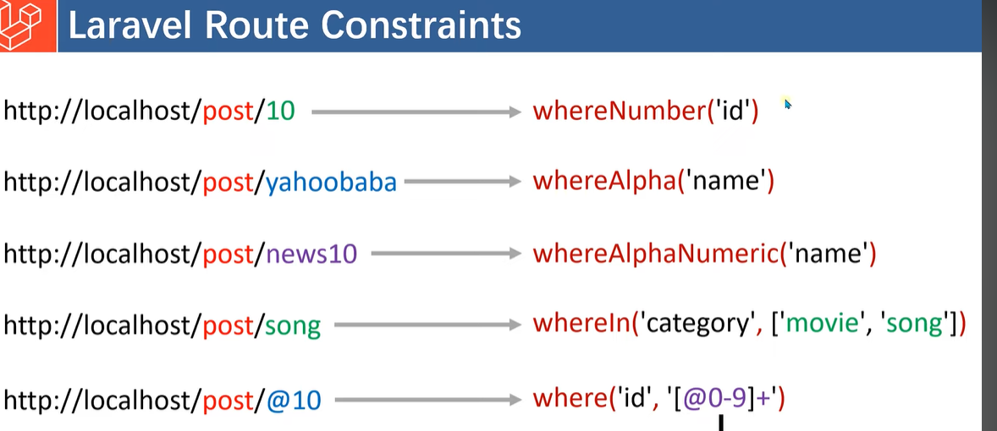

//WhereIN

Route::get('/category/{category}', function (string $category) {
return $category;
})->whereIn('category', ['movie', 'song', 'painting']);

//WhereNumber

Route::get('/post1/{id?}', function (string $id) {
return"Only Numbers : ". $id;
})->whereNumber('id');

//WhereAlpha

Route::get('/post2/{Name?}', function (string $Name) {
return"Only Alpha Numerics : ". $Name;
})->whereAlpha('Name');

//WhereAlphaNumeric

Route::get('/post3/{Name?}', function (string $Name) {
return" Alpha Numerics : ". $Name;
})->whereAlphaNumeric('Name');

LARAVEL DAY 10

NAMED ROUTES

Named routes allow the convenient generation of URLs or redirects for specific routes. You may specify a name for a route by chaining the name method onto the route definition:

Route::get('welcome',function(){
return view('welcome');
});

Route::get('/about',function(){
return view('aboutus');
})->name('about-us');

Route::get('/regis',function(){
return view('register');
})->name('regist-name');

URL REDIRECTION CODES

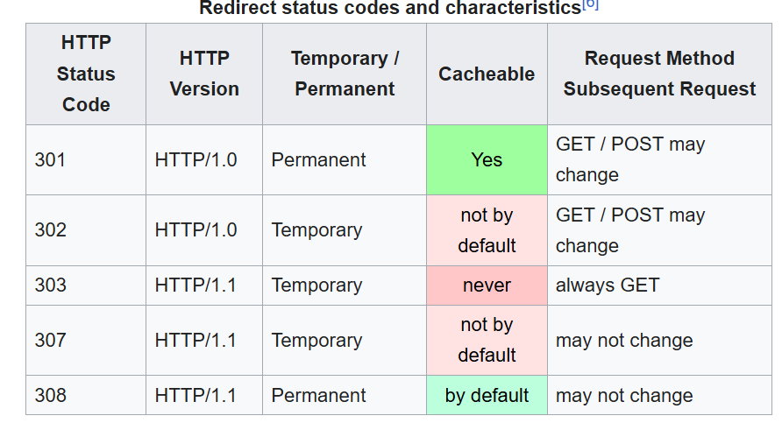

GROUPS ROUTES

Route groups allow you to share route attributes, such as middleware, across a large number of routes without needing to define those attributes on each individual route.

Route::prefix('page')->group(function(){

Route::get('welcome',function(){
return view('welcome');
});

Route::get('/about',function(){
return view('aboutus');
})->name('about-us');

Route::get('/regis',function(){
return view('register');
})->name('regist-name');

});

Route Prefixes
The prefix method may be used to prefix each route in the group with a given URI. For example, you may want to prefix all route URIs within the group with admin:

MIDDLEWARE

Middleware provide a convenient mechanism for inspecting and filtering HTTP requests entering your application. For example, Laravel includes a middleware that verifies the user of your application is authenticated. If the user is not authenticated, the middleware will redirect the user to your application's login screen. However, if the user is authenticated, the middleware will allow the request to proceed further into the application.
Additional middleware can be written to perform a variety of tasks besides authentication. For example, a logging middleware might log all incoming requests to your application. There are several middleware included in the Laravel framework, including middleware for authentication and CSRF protection. All of these middleware are located in the app/Http/Middleware directory.

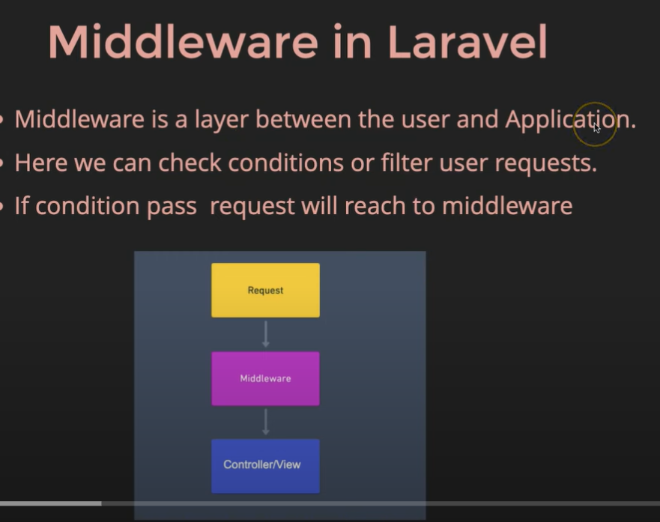

MIDDLEWARE TYPES

Global Middleware
Route Middleware
Group Middleware

LARAVEL DAY 11

CUSTOM MIDDLEWARE

php artisan make:middleware AlreadyLoggedIn

<?php

namespace App\Http\Middleware;

use Closure;
use Illuminate\Http\Request;
use Symfony\Component\HttpFoundation\Response;

class AlreadyLoggedIn
{
/**
* Handle an incoming request.
*
* @param \Closure(\Illuminate\Http\Request): (\Symfony\Component\HttpFoundation\Response) $next
*/
public function handle(Request $request, Closure $next): Response
{
if(Session()->has('loginId') && (url('login') == $request->url() || url('registration') == $request->url())){
return back();
}
return $next($request);
}
}

AUTH CHECK MIDDLEWARE

<?php

namespace App\Http\Middleware;

use Closure;
use Illuminate\Http\Request;
use Symfony\Component\HttpFoundation\Response;

class AuthCheck
{
/**
* Handle an incoming request.
*
* @param \Closure(\Illuminate\Http\Request): (\Symfony\Component\HttpFoundation\Response) $next
*/
public function handle(Request $request, Closure $next): Response
{
if(!Session()->has('loginId')){
return redirect('login')->with('fail','You have to login first.');
}
return $next($request);
}
}

Middleware and Responses

Of course, a middleware can perform tasks before or after passing the request deeper into the application. For example, the following middleware would perform some task before the request is handled by the application:

Assigning Middleware to Routes
If you would like to assign middleware to specific routes, you may invoke the middleware method when defining the route:
Route::controller(AuthenController::class)->group(function(){
Route::get('/registration','registration')->middleware('alreadyLoggedIn');
Route::post('/registration-user','registerUser')->name('register-user');
Route::get('/login','login')->middleware('alreadyLoggedIn');
Route::post('/login-user','loginUser')->name('login-user');
Route::get('/dashboard','dashboard')->middleware('isLoggedIn');
Route::get('/logout','logout');
});
ASSIGN THE MIDDLEWARE GLOBALLY
protected $middlewareAliases = [
'auth' => \App\Http\Middleware\Authenticate::class,
'auth.basic' => \Illuminate\Auth\Middleware\AuthenticateWithBasicAuth::class,
'auth.session' => \Illuminate\Session\Middleware\AuthenticateSession::class,
'cache.headers' => \Illuminate\Http\Middleware\SetCacheHeaders::class,
'can' => \Illuminate\Auth\Middleware\Authorize::class,
'guest' => \App\Http\Middleware\RedirectIfAuthenticated::class,
'password.confirm' => \Illuminate\Auth\Middleware\RequirePassword::class,
'signed' => \App\Http\Middleware\ValidateSignature::class,
'throttle' => \Illuminate\Routing\Middleware\ThrottleRequests::class,
'verified' => \Illuminate\Auth\Middleware\EnsureEmailIsVerified::class,
'isLoggedIn' => \App\Http\Middleware\AuthCheck::class,
'alreadyLoggedIn' => \App\Http\Middleware\AlreadyLoggedIn::class,
'token'=>\App\Http\Middleware\EnsureTokenIsValid::class,
];

Middleware Groups
Sometimes you may want to group several middleware under a single key to make them easier to assign to routes. You may accomplish this using the $middlewareGroups property of your HTTP kernel.
Laravel includes predefined web and api middleware groups that contain common middleware you may want to apply to your web and API routes. Remember, these middleware groups are automatically applied by your application's App\Providers\RouteServiceProvider service provider to routes within your corresponding web and api route files:

protected $middlewareGroups = [
'web' => [
\App\Http\Middleware\EncryptCookies::class,
\Illuminate\Cookie\Middleware\AddQueuedCookiesToResponse::class,
\Illuminate\Session\Middleware\StartSession::class,
\Illuminate\View\Middleware\ShareErrorsFromSession::class,
\App\Http\Middleware\VerifyCsrfToken::class,
\Illuminate\Routing\Middleware\SubstituteBindings::class,
],

'api' => [
// \Laravel\Sanctum\Http\Middleware\EnsureFrontendRequestsAreStateful::class,
\Illuminate\Routing\Middleware\ThrottleRequests::class.':api',
\Illuminate\Routing\Middleware\SubstituteBindings::class,
],
];

Middleware Parameters
Middleware can also receive additional parameters. For example, if your application needs to verify that the authenticated user has a given "role" before performing a given action, you could create an EnsureUserHasRole middleware that receives a role name as an additional argument.
Additional middleware parameters will be passed to the middleware after the $next argument:
LARAVEL DAY 12
CSRF TOKEN
Cross-site request forgeries are a type of malicious exploit whereby unauthorized commands are performed on behalf of an authenticated user. Thankfully, Laravel makes it easy to protect your application from cross-site request forgery (CSRF) attacks

<div>
<h1>
user form
</h1>
<form action="user" method="post">
@csrf
<input type="text" name="user" placeholder="enter name">
<br>
<br>
<input type="password" name="password" placeholder="enter name">
<br>
<br>
<button>Submit</button>
</form>
</div>

.TOKEN CONSOLE GENERTED
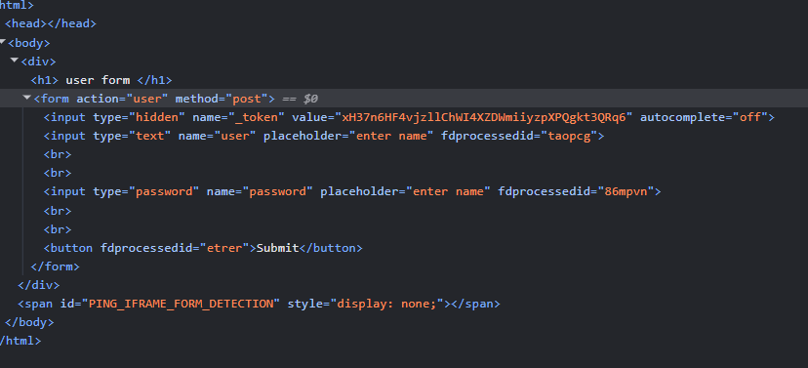
CONTROLLER

nstead of defining all of your request handling logic as closures in your route files, you may wish to organize this behavior using "controller" classes. Controllers can group related request handling logic into a single class. For example, a UserController class might handle all incoming requests related to users, including showing, creating, updating, and deleting users. By default, controllers are stored in the app/Http/Controllers directory.

LARAVEL DAY 13
SINGLE INVOKE CONTROLLER
If a controller action is particularly complex, you might find it convenient to dedicate an entire controller class to that single action. To accomplish this, you may define a single __invoke method within the controller:

///////////////////////////////////////////INVOKE CONTROLLER ////////////////////////////

Route::get('dif3/{id}/{Name}',ProvisionServer::class);

CONTROLLER GROUP WITH INVOKE METHOD

Route::controller(ProvisionServer::class)->group((function(){
Route::get('/dif/{id}','__invoke')->whereNumber('id');

Route::get('/dif2/{Name}','post')->whereAlpha('Name');
}));

CONTTROLLER WITH MIDDLEWARE AND ROUTES

////////////////////////////////////////////CONTROLLER WITH THE MIDDALWARE AND ROUTES ///////////////

// Route::controller(AuthenController::class)->group(function(){
// Route::get('/registration','registration')->middleware('alreadyLoggedIn');
// Route::post('/registration-user','registerUser')->name('register-user');
// Route::get('/login','login')->middleware('alreadyLoggedIn');
// Route::post('/login-user','loginUser')->name('login-user');
// Route::get('/dashboard','dashboard')->middleware('isLoggedIn');
// Route::get('/logout','logout');
// });

Resource Controllers
If you think of each Eloquent model in your application as a "resource", it is typical to perform the same sets of actions against each resource in your application. For example, imagine your application contains a Photo model and a Movie model. It is likely that users can create, read, update, or delete these resources.
Because of this common use case, Laravel resource routing assigns the typical create, read, update, and delete ("CRUD") routes to a controller with a single line of code. To get started, we can use the make:controller Artisan command's --resource option to quickly create a controller to handle these actions:
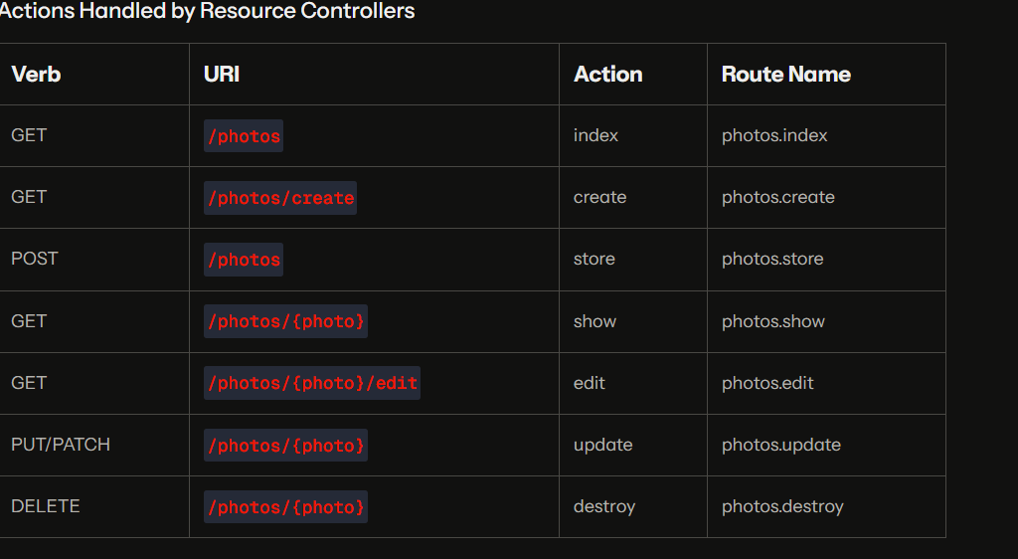
<?php

namespace App\Http\Controllers;

use App\Models\User;
use Illuminate\Http\Request;

class PhotoController extends Controller
{
/**
* Display a listing of the resource.
*/
public function index()
{
$user=User::all();
return ['result'=>$user];
}

/**
* Show the form for creating a new resource.
*/
public function create()
{

return ['result'=>'list Created'];
}

/**
* Store a newly created resource in storage.
*/
public function store()
{

return ['result'=>'New Member Added'];
}

/**
* Display the specified resource.
*/
public function show(string $id)
{
//
}

/**
* Show the form for editing the specified resource.
*/
public function edit($id)
{

}

/**
* Update the specified resource in storage.
*/
public function update(string $id)
{
return ["$id : Numbers Member Updated"];
}

/**
* Remove the specified resource from storage.
*/
public function destroy(string $id)
{
return ["$id : Numbers Member Deleted"];
}
}

REQUEST LARAVEL
Introduction
Laravel's Illuminate\Http\Request class provides an object-oriented way to interact with the current HTTP request being handled by your application as well as retrieve the input, cookies, and files that were submitted with the request.
<?php

namespace App\Http\Controllers;

use Illuminate\Http\Request;

class RequestController extends Controller
{
public function post(Request $request){
echo "Method : ".$request->method();
echo "<br>";
echo "Path : ".$request->path();
echo "<br>";
echo "Url : ".$request->url();
echo "<br>";
echo "CSRF TOKEN : ".$request->input('_token');
echo "<br>";
echo "Name : ".$request->input('email');
echo "<br>";
echo "Password : ".$request->input('password');
}
}

LARAVEL DAY 14

<?php

namespace App\Http\Controllers;

use Illuminate\Http\Request;

class RequestController extends Controller
{
public function post(Request $request){
echo "Method : ".$request->method();
echo "<br>";
echo "Path : ".$request->path();
echo "<br>";
echo "Url : ".$request->url();
echo "<br>";
echo "CSRF TOKEN : ".$request->input('_token');
echo "<br>";
echo "Name : ".$request->input('email');
echo "<br>";
echo "Password : ".$request->input('password');
echo "<br>";
echo "IP Address : ".$request->ip();
echo "<br>";
echo "IP Address : ".$request->getAcceptableContentTypes();
}
}
HTTP RESPONCES

Strings and Arrays
All routes and controllers should return a response to be sent back to the user's browser. Laravel provides several different ways to return responses. The most basic response is returning a string from a route or controller. The framework will automatically convert the string into a full HTTP response:

Route::get('/Responce',function(){
return "hello world";//this is the HTTP Generated responces from the Browser
});

///////////////////////////////////////RESPONCES LARAVEL////////////////////////////////////////

Route::get('/Responce',function(){
return "hello world";//this is the HTTP Generated responces from the Browser
});

Route::get('/Responce',function(){
return [1,2,3,4,5,6,7];//here we send the responce in the Array fromat
});
Route::get('/homeies', function () {
return response('Hello World', 200)
->header('Content-Type', 'text/plain');
});
//Eloquent Models and Collections
Route::get('/user1/{user}',function(User $user){
return response($user);
});

Attaching Cookies to Responses
//Responces with coockies
Route::get('/cookie',function() {
return response("Hello", 200)->header('Content-Type', 'text/html')
->withcookie('name','Virat Gandhi');
});

VIEWS
Of course, it's not practical to return entire HTML documents strings directly from your routes and controllers. Thankfully, views provide a convenient way to place all of our HTML in separate files.
Views separate your controller / application logic from your presentation logic and are stored in the resources/views directory. When using Laravel, view templates are usually written using the Blade templating language. A simple view might look something like this:

///////////////////////////////////////////VIEWS LARAVEL/////////////////////////////////

Route::view('/home','welcome');

Route::controller(ViewController::class)->group((function(){
Route::get('/home2/{name}','view')->whereAlphaNumeric('name');
Route::get('home3','view_two');
}
));

LARAVEL DAY 15
BLADE TEMPLATES
- Blade templates uses for reduce the code of n HTML doesn’t matter in which language we Are working HTML OR PHP
- Blade templates provides the Easiest way to create the View file
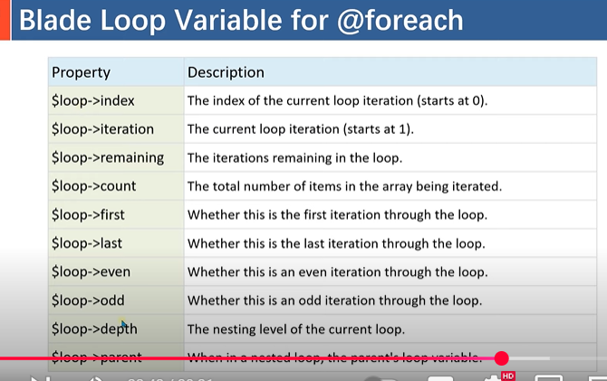

@foreach ($users as $user)
<tr>
<td>{{ $user->id }}</td>
<td>{{ $user->name }}</td>
<td>{{ $user->email }}</td>
<td>{{ $user->password }}</td>
</tr>
@endforeach
<!DOCTYPE html>
<html lang="en">
<head>
<meta charset="UTF-8">
<meta name="viewport" content="width=device-width, initial-scale=1.0">
<meta http-equiv="X-UA-Compatible" content="ie=edge">
<title>Document</title>
</head>
<body>

{{"Hello"}}
<br>
{{$name}}
<br>
{{--HTML CODE--}}
{{!! "<h1>Sudhikaran Jaruri he</h1>" !!}}
<br>
{{--JAVSCRIPT CODE WRITE SYNTAX --}}
{{!! "
<script>alert('Deep Jadav')</script>" !!}}

@php
$Addtion=10+30;
$nas=['deep','rahu','jason'];

@endphp

<ul>
@foreach ($nas as $x)

{{--ITERATION FOREACH METHOD--}}

{{-- <li>{{$loop->iteration}}-{{ $x }}</li> --}}

{{--INDEX FOREACH METHOD--}}

{{-- <li>{{$loop->index}}-{{ $x }}</li> --}}

{{--COUNT FOREACH METHOD--}}

<li>{{$loop->count}}-{{ $x }}</li>

@endforeach

@php
@endphp

</ul>
</body>
</html>

BLADE TEMPLATES MAIN DIRECTRIVIES

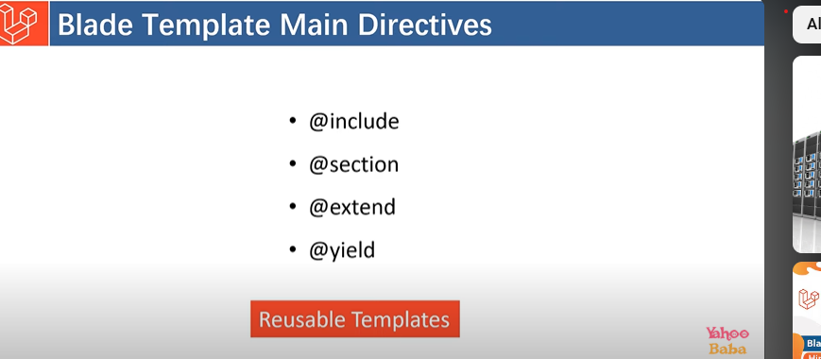

@yield
- Defines a section in a blade template
- Allows child views to inject code into the section
- For example, @yield('title') defines a section for the title
@section
- Fills the sections defined by @yield
- Used in a child view that extends the parent view
- For example, @section('title', 'Page Title') fills the title section
- <!DOCTYPE html>
- <html lang="en">
- <head>
- <meta charset="UTF-8">
- <meta name="viewport" content="width=device-width, initial-scale=1.0">
- <meta http-equiv="X-UA-Compatible" content="ie=edge">
- <title>Document</title>
- </head>
- <body>
- @extends('welcome')

- @section('content')
- <h1>hey</h1>
- @endsection
- </body>
- </html>

LOOP VARIABLES

Property | Description
$loop->index | The index of the current loop iteration (starts at 0).
$loop->iteration | The current loop iteration (starts at 1).
$loop->remaining | The iterations remaining in the loop.
$loop->count | The total number of items in the array being iterated.
$loop->first | Whether this is the first iteration through the loop.
$loop->last | Whether this is the last iteration through the loop.
$loop->even | Whether this is an even iteration through the loop.
$loop->odd | Whether this is an odd iteration through the loop.
$loop->depth | The nesting level of the current loop.
$loop->parent | When in a

